Planning Process in Cursor

- Make a Product Requirements document (PRD)
The most important aspect of starting off on the right foot is making a PRD.
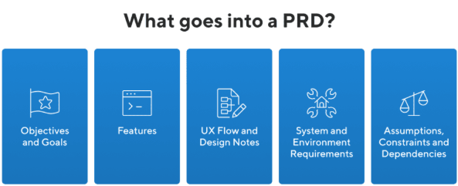
- Objective/Goal: Explain why you are building this and what you hope to accomplish. Answer questions like
  - Who is your target customer?
  - What pain point are you trying to eliminate/solve for the customer?
  - What business results should this drive? (Revenue, Engagement, subscription rate, etc)
  - Are there any constraints we are operating under? (time, tech stack, development cost, etc.)

- Features: For each feature, include a description, goal, and use case at a minimum. Additional details, such as out-of-scope items, may be specified here.

- UX Flow & Design Notes: Most organizations complete the UX design of features after the PRD has been reviewed and accepted. However, there may be some general guidance required at this stage to ensure the release objectives are met. This is not the place for pixel-perfect mockups or wireframes that map out every possible scenario; instead, it is used to describe the overall user workflow.

- System & Environment Requirements:
Every System has the following layers:
- How is the data presented? Front End (a.k.a Client Side) Layer; runs in the user's browser or App and handles the UI/UX. They use the API layer over Hypertext Transfer Protocol Secure (HTTPS) to encrypt data between the device and the website (in the back end), so others on the network cannot read it. API calls are usually made to end points (one URL + one HTTP method) within the API Layer.
- How is the data processed and feteched? ; Back End (a.k.a. Server Side) Layer; Code that runs on the servers, implementing the app logic is called the domain Models. Authentication & API’s called Domain Services (the whole interface, i.e., the full set of operations and data contracts and back-end expenses (all routes + request/response schemas + auth rules). The API is the doorway that the back-end exposes to the front-end. The designs to expose your back end are through REST API or GRAPHQL API.
- Hoew is the data stored?; Database Storage Layer: systems that store and query persistent data
- How is the data hosted? Infrastructure Layer: where and how the app is hosted, deployed, scaled, and monitored
- DevOps Layer: Version control, monitoring, and logging

- Which end-user environments will be supported (such as browsers, operating systems, memory, and processing power, etc.).
  - Supported platforms and OS; Desktop, mobile web, iOS/Android, Windows/macOS/Linux
  - Which browsers are supported (Chrome, Safari, Edge, etc.) and responsive breakpoints that must work well.
  - Which browsers are supported (Chrome, Safari, Edge, etc.) and responsive breakpoints that must work well.
  - Required API’s, databases, auth providers, payment gateways, analytical tools.
- Assumptions, Constraints & Dependencies: List out what is expected of users, any limits for the implementation to be aware of and any outside elements required for the final solution to be functional.

- Toggle between Plan and Ask so that all information is in the same place. Refrain

- Prompts to tighten up the PRD
- Make the plan extremely concise. Sacrifice grammar for the sake of concision. At the end of each version of the plan, provide a list of unresolved questions to address based on the key elements of the product requirement document, if any.
- Break the code execution plan into distinct chunks (agents with names) so that each chunk can be coded/tested, and debugged separately.
Notes: This helps to keep the context window relevant. This can be seen at the bottom right side of the plan window
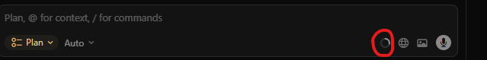
- Please develop the tech stack to build for scale but also minimising initiate costs when the product is in MVP stage.

Definitions
- Repo; A repo, short for repository, is a central location where you can store and manage your software projects. It acts as a centralized hub that tracks changes, allows collaboration among team members, and provides a history of modifications made to the code. In simple terms, a repo is like a digital filing cabinet for your code, ensuring that everything is organized, accessible, and secure
- Postgres versus SQL; Postgres (PostgreSQL) is a database system, while SQL is a language used to talk to databases.

